Incident Triggered Through API :

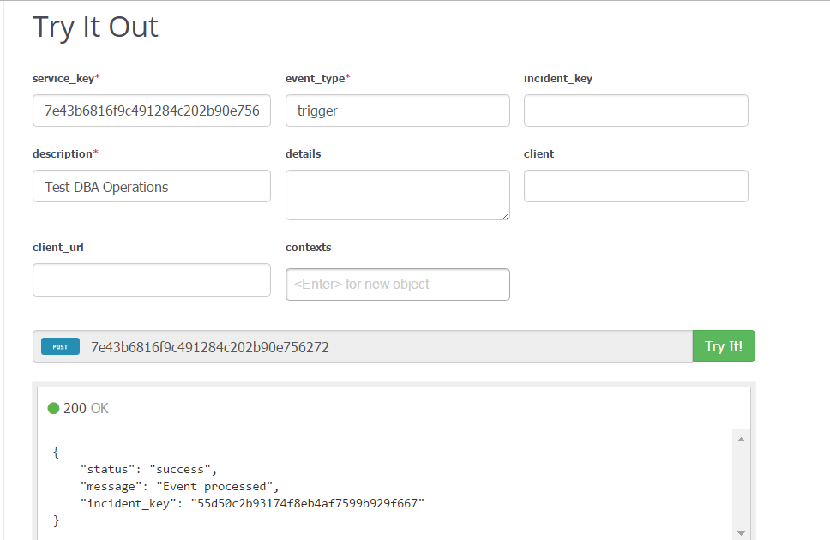

Messages In Spark :

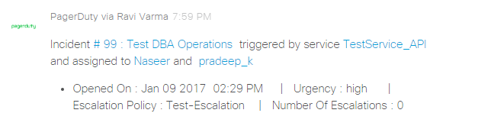

Incident acknowledge through API :

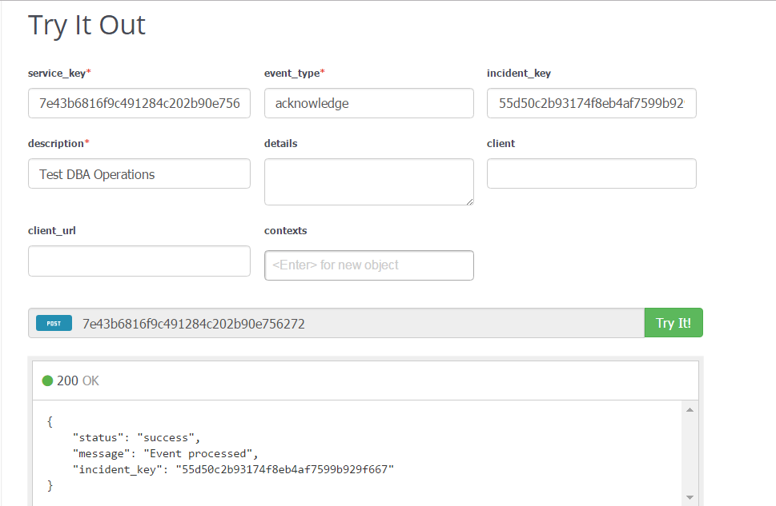

Message In Spark :

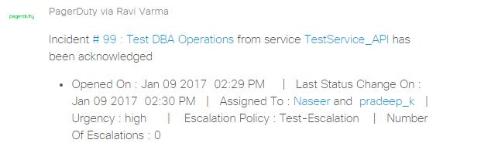

Incident resolved through API :

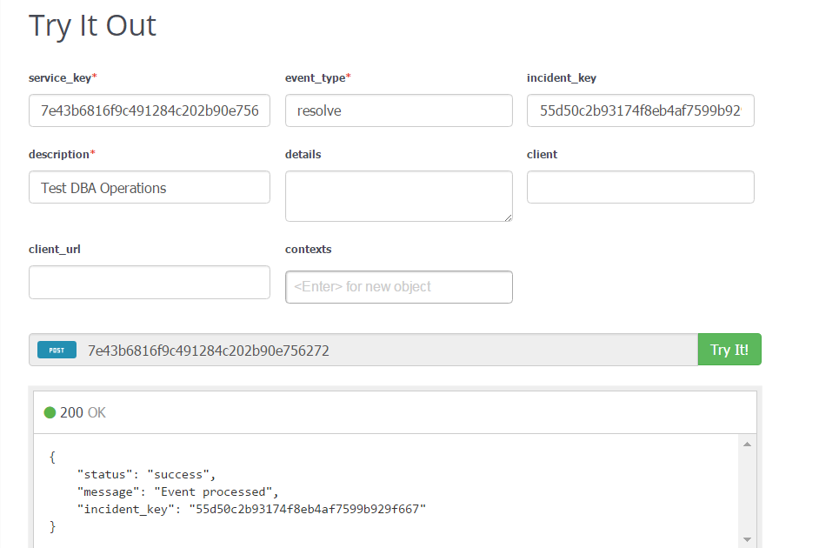

Message In Spark :

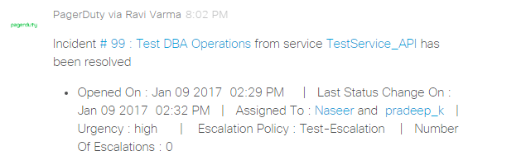

Incident triggered through webhook :

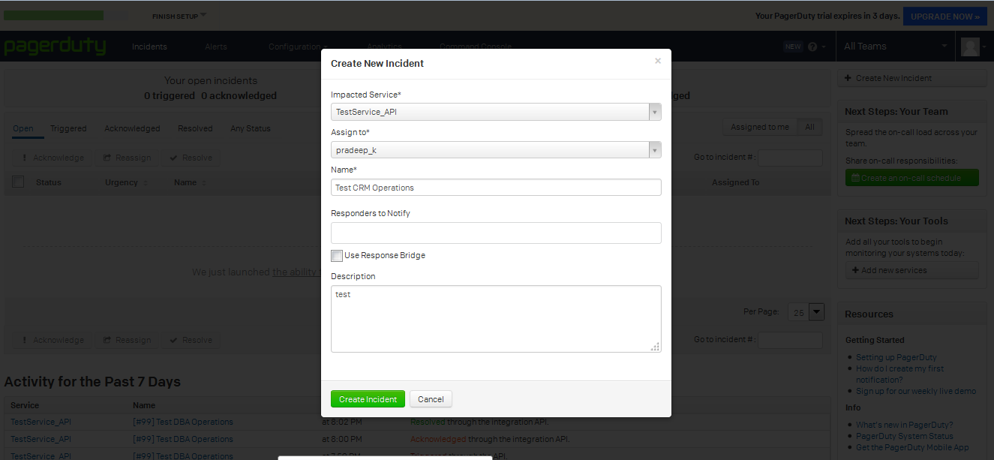

Message In Spark :

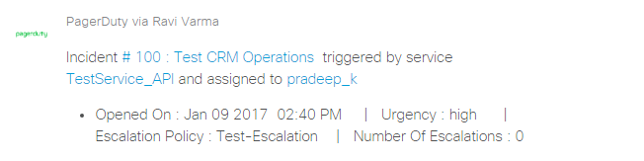

Incident manually assign :

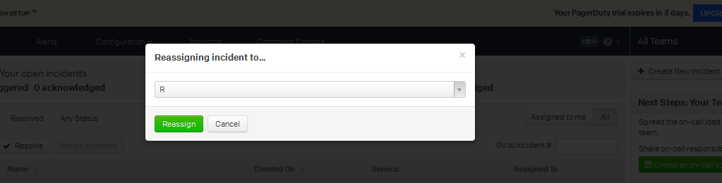

Message In Spark :

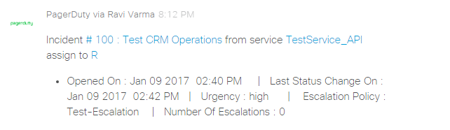

Incident Escalated :

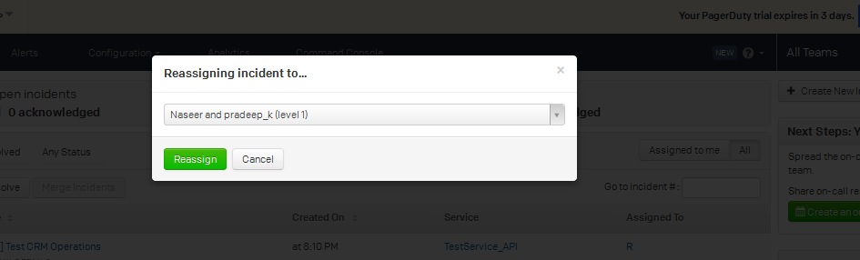

Message In Spark :

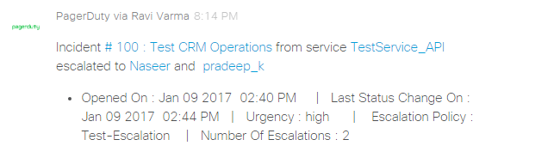

Incident Delegate :

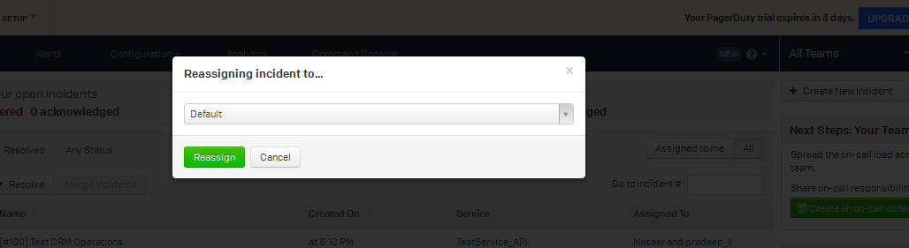

Message In Spark :

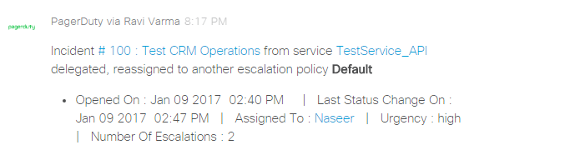

Incident acknowledge, Message in spark :

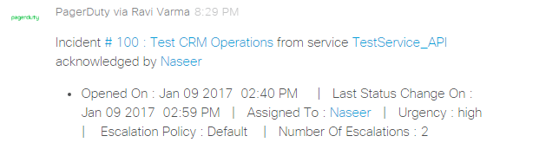

Incident resolved, Message in spark :

